1. Previous Homework

9.7 A machine being used for packaging seedless golden raisins has been set so that, on average, 15 ounces of raisins will be packaged per box. The quality-control engineer wishes to test the machine setting and selects a sample of 30 consecutive raisin packages filled during the production process. (See raisins.xls).

(a) Is there evidence that the mean weight per box is different from 15 ounces? (Use α = 0.05.)

H0: μ = 15g
H1: μ ≠ 15g

$\overline{X}=\text{15}\text{.}\text{11}$, s = 0.4058

$s_{\overline{X}}=\frac{s}{\sqrt{n}}$ = .4058/√30 = 0.0741

$$t=\frac{\overline{X}−μ}{s_{\overline{X}}}=\frac{\text{15}\text{.}\text{1133}−\text{15}}{\text{.}\text{0741}}=\frac{0\text{.}\text{1133}}{\text{.}\text{0741}}=1\text{.}\text{53}$$

p-value (two-tailed) = area in t distribution (with 30 – 1 = 29 df) above t plus area
below –t.

= T.DIST.2T(1.53, 29) = 0.1369 > 0.05

H0 not rejected, no evidence of difference from 15g.

Conclusion: "We do not reject the null hypothesis."

2. Comparing Two Means: Independent Groups

In the last lectures we learned how to test whether a single group mean differs from some hypothesized value. Now we consider a somewhat more common problem: how to test whether the means of two groups (e.g., patients given a new drug vs. placebo) are significantly different from each other.

The procedure parallels that for testing a single mean:

- State null and alternative hypothesis, H0 and H1.
- Choose an α level (e.g., 0.05); decide on 1- or 2-tailed test.
- Calculate test statistic: z (if population variances known) or t (otherwise).
- Compute p-value for test statistic.
- if p ≤ α, reject null hypothesis

Usually our null hypothesis is that the means of both groups are equal. For a two-tailed hypothesis test (the preferred method), our alternative hypothesis is that the means are not equal. Thus:

H0: μ₁ = μ₂
H1: μ₁ ≠ μ₂

Alternatively, for a one-tailed test, we may choose as H1 either μ₁ > μ₂ or μ₁ < μ₂.

Note: more generally, we might wish to test the hypothesis that μ₁ exceeds μ₂ by some constant c. Our null and alternative hypothesis would then be H0: μ₁ = μ₂ + c and H1: μ₁ ≠ μ₂ + c (for a 2-tailed test).

Recall that when the population standard deviation is not known, we test a hypothesis for a single mean using the t-statistic, and calculated t as:

$t=\frac{(\overline{X}−μ)}{s_{\overline{X}}}$,
where $s_{\overline{X}}$ is the standard error of the sample mean, equal to the sample standard deviation (s) divided by the sqrt(n).

We follow a similar approach in comparing two sample means (we'll assume that the population standard deviations are not known). That is, we will construct a t-statistic. The numerator of the t-statistic here is fairly obvious: $({\overline{X}}_{1}−{\overline{X}}_{2})−(μ_{1}−μ_{2})\text{.}$ When H0 is μ₁ = μ₂, this reduces to simply: $({\overline{X}}_{1}−{\overline{X}}_{2})\text{.}$

For the denominator, we need to know the appropriate standard error, or in other words, the standard deviation of the sampling distribution for the difference of two sample means. We are helped here by an important principle. If any two variables A and B are independent, then:

$${}^{}σ_{A−B}^{2}=σ_{A}^{2}+σ_{B}^{2}$$

If we sample both groups randomly, their sample means are independent, so

$${}^{}σ_{{\overline{X}}_{1}−\overline{X}2}^{2}=σ_{{\overline{X}}_{1}}^{2}+σ_{{\overline{X}}_{2}}^{2}$$

and

$${}^{}σ_{{\overline{X}}_{1}−\overline{X}2}^{}=\sqrt{σ_{{\overline{X}}_{1}}^{2}+σ_{{\overline{X}}_{2}}^{2}}$$

That is, the standard error for the difference of two sample means is equal to the square root of the sum of the variances of the sample means.

Since we don't know the population variances, we must estimate them from our sample variances for groups 1 and 2, and our general t-statistic formula is:

$$\text{t = }\frac{({\overline{x}}_{1}\text{ - }{\overline{x}}_{2})\text{ - }(μ_{1}\text{ - }μ_{2})}{\sqrt{\frac{s_{1}^{2}}{n_{1}}\text{ + }\frac{s_{2}^{2}}{n_{2}}}}$$
.
In the special case of H0: μ₁ = μ₂, this reduces to:

$$t\text{ = }\frac{{\overline{x}}_{1}\text{ - }{\overline{x}}_{2}}{\sqrt{\frac{s_{1}^{2}}{n_{1}}\text{ + }\frac{s_{2}^{2}}{n_{2}}}}$$

Note that for the denominator we are making use of the formulas:

$s_{{\overline{X}}_{1}}^{2}=\frac{s_{1}^{2}}{n_{1}}$ and $s_{{\overline{X}}_{2}}^{2}=\frac{s_{2}^{2}}{n_{2}}$.

The degrees of freedom (df) for the t-statistic here are equal to:

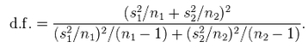

Example

For a random sample of n₁= 10 men, mean height = 71.44 inches and s²₁ = 8.561 inches.
For a random sample n₂ = 61 women, mean height = 65.5 inches and s²₂ = 10.407 inches.
Is this a statistically significant given a 2-tailed test and α = 0.05.

H0: μ₁ = μ_{2.}
H1: μ₁ ≠ μ₂ .
Men's variance of mean: $s_{{\overline{X}}_{1}}^{2}=\frac{s_{1}^{2}}{n_{1}}$ = 8.561 / 10 = 0.8561.

Women's variance of mean: $s_{{\overline{X}}_{2}}^{2}=\frac{s_{2}^{2}}{n_{2}}$ = 10.407 / 61 = 0.1706.

Variance(mean 1 – mean 2): $s_{{\overline{X}}_{1}−\overline{X}2}^{2}=s_{{\overline{X}}_{1}}^{2}+s_{{\overline{X}}_{2}}^{2}$= 0.8561 + 0.1706 = 1.0267.

Std. err. (mean 1 – mean 2): sqrt(1.0267) = 1.0133 .

$$t\text{ = }\frac{{\overline{x}}_{1}\text{ - }{\overline{x}}_{2}}{\text{Std}\text{.}\text{Err}({\overline{x}}_{1}\text{ - }{\overline{x}}_{2})}$$

= (71.44 – 65.5) / 1.0133 = 5.84.

To calculate the exact p-value we would need to compute the df, but even from above it is evident that this is a very large t value and probably indicates a statistically significant (p < α) difference.

Provisos

- If the population standard deviations of both groups are known, then we compute a z-statistic, and use as the standard error (denominator)${}^{}σ_{{\overline{X}}_{1}−\overline{X}2}^{}=\sqrt{σ_{{\overline{X}}_{1}}^{2}+σ_{{\overline{X}}_{2}}^{2}}$.

- If, for theoretical reasons, we believe that both groups have the same population standard deviation (even though we don't know what that is, then the t-test is can be revised slightly, producing the pooled variance t-test the difference between two means. However, this introduces a new layer of complication: determining whether the two sample variances are close enough in value to support the assumption that they estimate a common population variance. Before computers were widespread, the pooled variance t-test had the advantage of greater computational ease. Now it is, arguably, no longer necessary and we will not use it here.

3. Independent Groups t-test with JMP

- Start JMP
- Make new Data Table
- Paste/type data into Data Table
- Note: one column will have continuous scores (Y variable) and the other (X variable) will have a group designator (1 vs. 2).
- Right-click the top of the column with the X variable
- In dropdown menu, check Modeling Type > Nominal (this will treat that variable as a group identifier)
- Highlight columns with the Y and X variables.
- Analyze > Fit Y by X
- Designate Y (Response) and X (Factor) variables in pop-up window, press OK

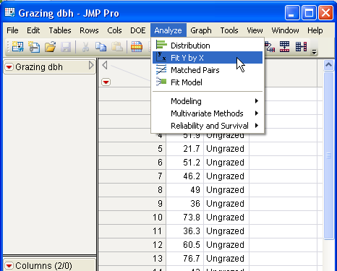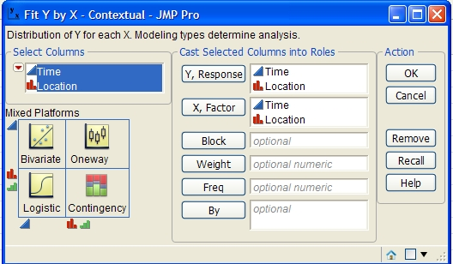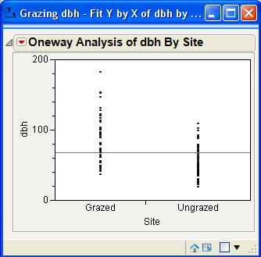
Step 8 Step 9 Step 10

10. A report like the following will appear.
11. Click red arrow of report and select t-test.

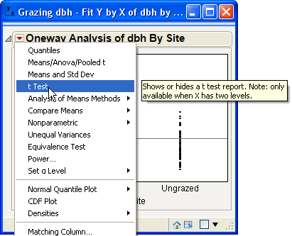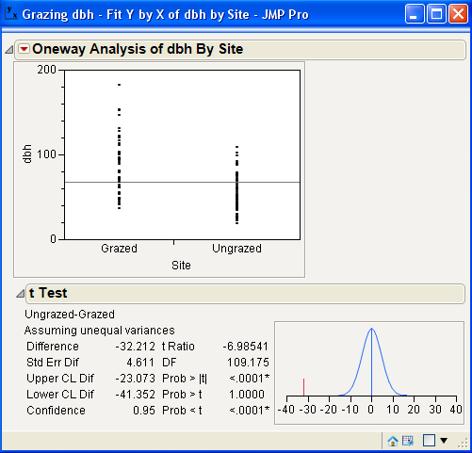
Step 11 Step 12

12. Results appear in new section of report.

p < α , reject H0

4. Comparing Two Means: Paired Data

In the preceding section we considered how to test a difference of two means for independent groups. Now we look at how to do the same thing with dependent groups – specifically, when observations from both groups can be matched one-for-one. This method is called the matched-pairs t-test, paired t-test, or repeated measures t-test. Some example applications:

- Do the same patients show improvement after vs. before a treatment?
- If Treatment A and Treatment B are given to the same patients, which works better?

This procedure is very simple, because it is ultimately just a test of a single mean.

The paired t-test can be understood as a t-test of a single mean, where the variable of interest is a new variable constructed by taking the difference between X₁ and X₂ (D = X₁ – X₂), with n – 1 df, where n = the number of pairs.

That is, let X₁ and X₂ be two measurements (e.g., Pre and Post scores) made on the same sample of subjects/objects. Define the new variable

Difference = D = X₁ – X₂

for all cases. If our scientific hypothesis is that the means of X₁ and X₂ are different (e.g., one treatment is better than another other), our null and alternative hypotheses are simply:

H0: μ_{D} = 0 (i.e., μ₁ = μ₂)
H1: μ_{D} ≠ 0 (i.e., μ₁ ≠ μ₂)

where μ_{D} is the (population) mean difference of X₁ and X₂, equal to μ₁ – μ₂.

Alternatively, if we want to test for a difference of, say, greater than some value c:

H0: μ_{D} = c (i.e., μ₁ = μ₂ + c)
H1: μ_{D} > c (i.e., μ₁ > μ₂ + c)

the null hypothesis is for no difference (H0: μ_{D} = 0) we our test statistic is:

t =

where: n is the number of pairs.
s_{D} is the sample standard deviation computed for D = (X₁ – X₂).

As before, we then determine the probability (p) of this t value and compare it to a pre-specified α (e.g., α = 0.05). If p < α, reject H0.

5. Paired Groups t-tests in Excel and JMP
Excel
1. State H0 and H1; choose α.
2. Enter X1 and X2 values side by side in adjacent columns.
3. Make a new column for D = (X1 – X2).
4. Calculate mean and sample standard deviation of D.
5. Compute t statistic t = ${\overline{D}}/({s_{\overline{D}}}/{\sqrt{n}})$ (assuming H0: μ_{D} = 0)
6. Use Excel function T.DIST to find p = probability in tail area(s) of t distribution.
7. If p < α, reject H0.

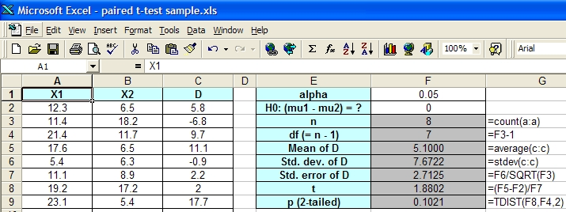
Figure 1

JMP
1. Paste X and Y variables into two separate columns, side by side.
2. Highlight columns
3. Analyze > Matched Pairs
4. In pop-up window, designate both variables as "Y, Paired Responses", and press OK

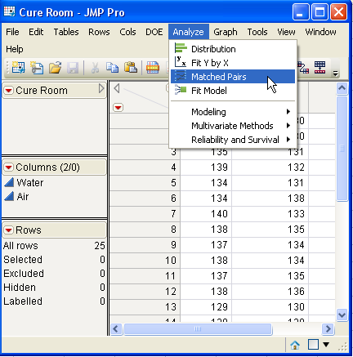  Step 3 | 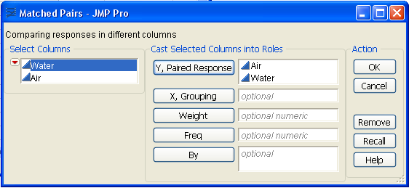  Step 4 | 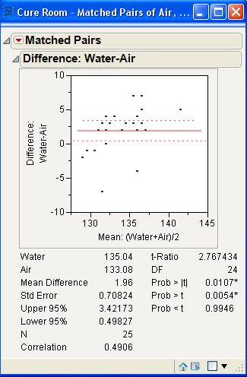

Homework

Review pp. 413–419 (independent groups t-test); don't worry about the pooled-variance t-test.
Review pp. 427–421 (paired t-test)
Review pp. 510–511 (sampling distribution of a proportion)

Work Problem 9.14 (part a and d only) using JMP.

- data are in phone.xls (don't paste the names 'Time' and 'Location' into JMP)
- Assume population variances are unequal.

A problem with a telephone line that prevents a customer from receiving or making calls is disconcerting both to the customer and to the telephone company. These problems can be of two types: those that are located inside a central office, and those located on lines between the central office and the customer's equipment. The following data represent samples of 20 problems reported to two different offices of a telephone company and the time to clear these problems (in minutes) from the customers' lines:

(a) Assuming that the population variances are equal unequal, is there evidence of a difference between the two central offices with respect to average time to clear these problems (in minutes)? (Use α = 0.05.)

(d) Find the p-value in part (a) and interpret its meaning.

Optional Video: Difference of Sample Means Distribution
http://www.youtube.com/watch?v=TcIDXqmt74A

Video: Hypothesis Test for Difference of Means
http://www.youtube.com/watch?v=N984XGLjQfs

